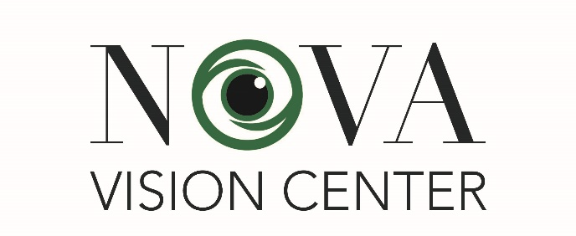
Dr. Christopher Renner
Dr. W. Dodge Perry
Dr. Sarah Terlesky
Dr. Alexa Vinh
Optometrists
family and specialty eye care
WAIVER FOR INSURANCE COMPANIES and PATIENT PAYMENT AUTHORIZATION

Patient Name___________________________ Patient Birthdate____________________

We, Nova Vision Center (Ralph A. Swetlow, LTD – Drs. Renner, Perry, Terlesky, and Vinh OD), are a provider for the following insurance companies (but not limited to), Aetna, Anthem, Carefirst, Cigna, GEHA, Medicare, Tricare, United Health Care and UMR.
These are managed care plans who have contracted with employer groups and have different fee schedules and coverage schedules. We will file all fees to the appropriate insurance company (listed above) on your behalf and collect for all covered fees according to their contracts.
By signing below, you, the patient, are primarily responsible to pay all of the co-pays and non-covered items as designated by your insurance company. These items may include refractions (92015), contact lens services (92310), sensorimotor exams (92060) developmental testing (96110 to 96116), gonioscopy (92020), special reports or forms (99080), or photography (92250). In the case of post cataract surgery glasses, anything beyond the most basic frame and lenses will be filed as deluxe frame V2025 and deluxe lenses V2781. There may be other items that are not covered and we will discover these when we file the insurance claim and receive the EOB. In the event that the patient’s insurance fulfills their obligation, this office will reimburse the patient for any overpayment made by the patient.

I further understand that I may require a referral depending on my insurance plan in order for services to be covered in this office. If I do not bring a referral, I understand that I am responsible for all the charges incurred at this office.
I understand that if payment is not received within 90 days of the date of service, from me or my insurance company, the account will be turned over to a collection agency. I understand that if I agree to make monthly payments and the account becomes delinquent for 90 days, it will be turned over to a collection agency. There will be an administrative charge of $50.00 added to the balance of any unpaid portion of the bill for any account turned over to the collection agency. I understand that if I have borrowed equipment, glasses, contacts or other materials from the office that I am responsible for returning them in good condition or I will be charged the full amount for these items.

MEDICAL COVERAGE and VSP (Vision Service Plan) COVERAGE and AUTHORIZATION
VSP provides basic eye care services and a contribution toward eyeglasses or contact lenses on a schedule determined by your employer. It allows you to obtain routine vision care services (healthy eye exam) and basic eyeglasses with a small co-payment.
VSP does not cover several tests which are now considered the standard of care. It does not cover special testing to diagnose or treat many eye diseases or developmental eye disorders.
The following services are not covered by VSP, but might be covered by your major medical insurance. Some tests for certain patients might be required at every visit, while others are performed only on a periodic basis, depending on age and diagnosis.
Routine services which are not covered by VSP and may or may not be covered by most major medical insurances:
- Refraction (92015)$55-65
- Contact lens evaluation $100-300 depending on lens necessity, Scleral Lenses $1500-2000
- OPTOS-Retinal photography-recommended for all patients at every annual exam $39-$75
- Visual field testing (92081-92803) detailed test of peripheral vision, usually performed at the second examination, then every 5 - 10 years thereafter.$75-125
- Developmental Report/School Report (99080) Workman's Comp or other Detailed Report $75-125
- Sensorimotor exam (92060) determination of special visual needs, such as prism or vision training for children and adults with developmental vision or eye coordination problems $75-95
- Other testing, including follow-up office visits, OCT optic nerve (92133) $75, or retinal scanning (92134) $75, developmental testing (96110-96116) $75-155, visual evoked potential (VEP)/PERG (95930) $215 etc.
- RightEye (RTO) RightEye Vision Therapy (92065) $100-115 per session (where your health information may be shared with RightEye ( Eye Tracking System)
- Screening for Macular Degeneration (92284) AdaptDx $85-100
- DMERC post Cataract Surgery Glasses in excess of the cost of basic frames and lenses
- Dry Eye Evaluations $39-200,IPL (Intense Pulse Light) – specialized treatment for dry eye/facial inflammation $300-$500 per visit
- Myopia control – custom pricing depending on treatment modality $600-2000
- Contact lens evaluations are required every year for contact lens wearers and may not be covered by VSP or your major medical insurance. You will be responsible for all of the balance not covered by VSP or insurance (92310, 92311, 92312) $85-$250- may be more for specialty fittings or multiple month or yearly supply.

OFFICE PRIVACY POLICY
Please note that we store patient’s records for seven years from the last date of service or until the patient reaches twenty-one years of age: whichever is longer. The records are then destroyed.

I understand the patient payment policy.

I acknowledge that I have accessed the copy of Nova Vison Center (Ralph A Swetlow LTD) Notice of Privacy Practices January 1, 2024.

I authorize the release of any necessary information, including medical information, for this or any related claim.

Relationship to patient: Self Spouse Parent Other

___________________________________________ _____________________________________
Signature of patient/parent or guardian Date
Revised 2-1-24
patient forms/waiver for insurance…authorization 2-1-24 with logo regular print 2-1-24

